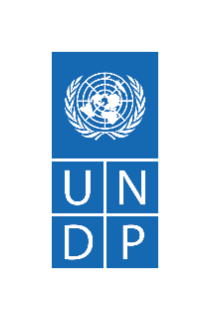


United Nations Development Programme
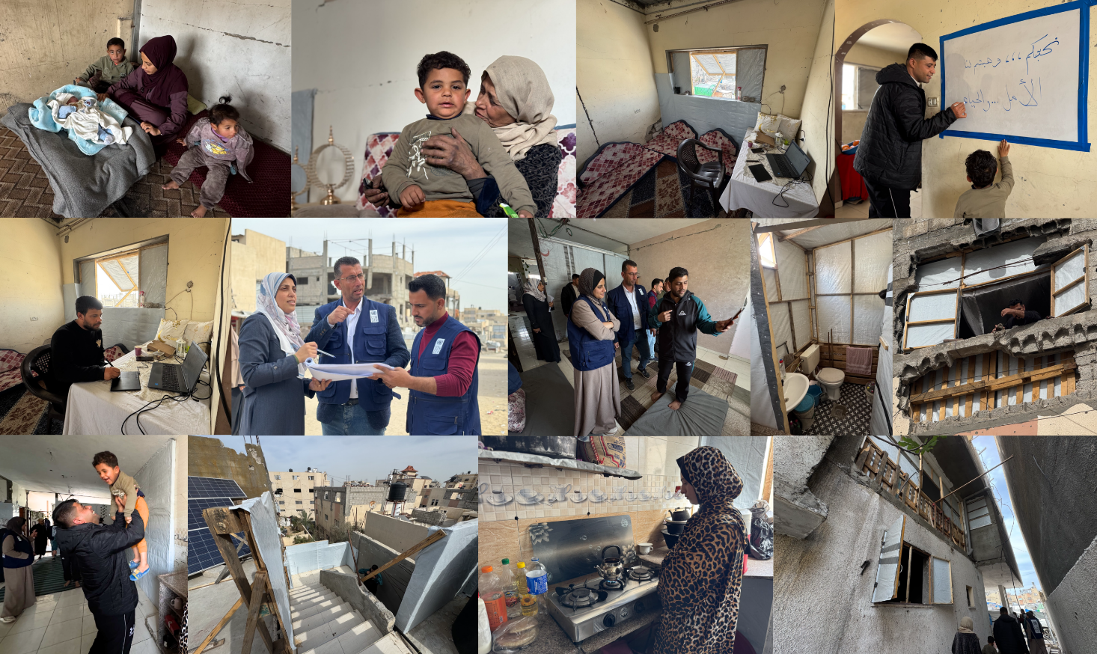
Programme of Assistance to the Palestinian People

Project Report
Project Title | Gaza Emergency Shelter Rehabilitation and Winterization
Budget | KWD 300,000 (USD 977,199)
Location | Gaza Strip, oPt
Reporting Period | June 2025 – February 2026
Submission Date | 28 February 2026
Donor | Arab Fund for Economic and Social Development
UNDP Contact Person | Alessandro Mrakic, UNDP/PAPP Head of Sub-Office Gaza  alessandro.mrakic@undp.org

- Background
The Gaza Emergency Shelter Rehabilitation and Winterisation Project, funded by the Arab Fund for Economic and Social Development, aims to rehabilitate partially and severely damaged housing units for displaced and vulnerable households, including women-headed families and persons with disabilities. Its timeframe is June 2025 until February 2026, with an allocated budget of KWD 300,000 (USD 977,199).
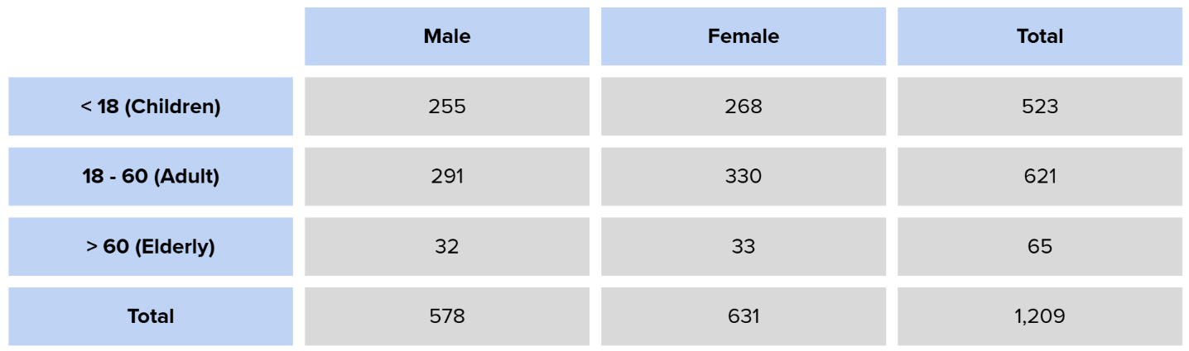
Originally designed to support 200 households (around 1,200 individuals), the project successfully rehabilitated 232 housing units, exceeding the initial target by 16 per cent. Emergency rehabilitation works comprised the installation of kitchens and sanitary facilities, repair of doors and windows, and provision of winterisation measures with materials immediately available on the local market. These interventions allowed families to remain in their homes, or to return home from tents, and provided protection from harsh winter conditions. Below is a summary of the project’s beneficiaries reached: a total of 1,209 individuals, 52 per cent being female, 43 per cent children, and 5 per cent elderly:
Vulnerable community members were prioritised for assistance. Of the households reached, 42 have at least one person with disabilities, and an additional 42 are women-led.
Working with locally procured materials under the severe supply constraints faced in Gaza, rehabilitation teams sealed doors and windows, providing families with basic protection from wind and rain. The installation of simple kitchen facilities, including countertops and sinks, restored a sentiment of routine to daily life, allowing families to prepare food in a clean, sheltered space rather than in the open or in the hazardous conditions of makeshift sites. Rehabilitated washrooms restored a sense of privacy and dignity.
For families who had been displaced repeatedly over two years, the impact of returning home extends beyond physical repairs. Children who had been prone to frequent illness in tent conditions showed noticeable improvements in both physical and mental health once back in enclosed homes. Residents spoke of the relief of familiar surroundings, of children having a safer space to sleep and play, and of the comfort of some restored routine after so long in circumstances entirely outside their control.
Despite challenges such as material shortages and reliance on second-hand items (applied only as a carefully considered exception), the project has now completed all works on the ground. Over 200 families were enabled to remain in or safely return to their homes, benefiting from safer, more functional, and more weather-resilient living conditions.
- Achievements Over the Reporting Period
By November 2025, field assessments had been conducted, damage levels documented, and beneficiary households selected based upon approved criteria. Technical documents, Bills of Quantities (BoQs), and tender packages were completed; contracts were awarded to two contractors following an open and competitive bidding process; and all selected sites were handed over to the contractors on 24 November 2025.
Emergency rehabilitation works of partially and severely damaged housing units began on 29 November 2025. A structured workplan (Annex 1) guided rehabilitation works, dividing activities into sequential work packages for quality control and monitoring purposes.
As of 25 February 2026, rehabilitation of a total of 232 housing units has been fully completed. A phased implementation approach enabled continued progress toward targets in a volatile operating context, with the status of each Lot of housing units reflected below:
- Lot 1: 3 packages covering an initial 98 housing units; and an additional package of 19 units were completed (100%). [total of 4 packages; 117 units]
- Lot 2: 3 packages covering an initial 102 housing units; and an additional package of 13 units were completed (100%). [total of 4 packages; 115 units]
As part of the emergency rehabilitation works, partially and severely damaged housing units are fortified to the extent possible with materials available locally, not including structural repairs. For example, temporary internal and external walling is installed using tarpaulin sheets and wooden framing; metal profiles and corrugated metal sheets reinforce walls and roofs; and aluminum doors, door frames, and windows are repaired or installed where required using aluminum materials. Kitchens are improved by installing granite countertops and sinks and repairing cabinetry. Plumbing is made functional again by installing and repairing washrooms, flush systems, taps, and piping. Required materials, like wood, tarpaulins, and fixtures, are promptly delivered to sites to enable continued progress.
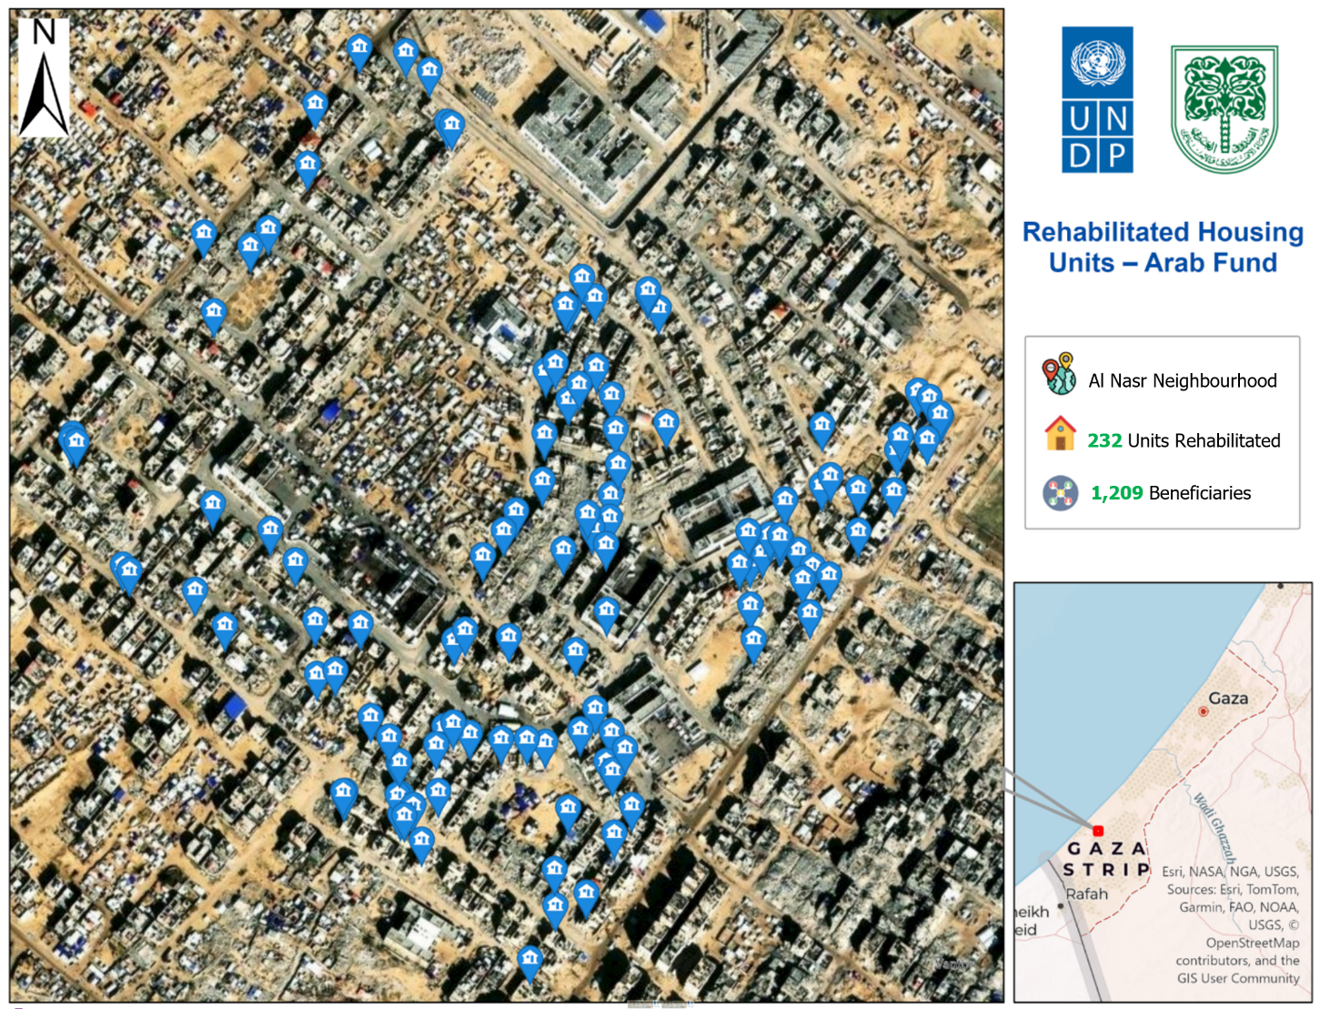
All 232 rehabilitated housing units are located in Al Nasr Neighbourhood, Khan Younis governorate, as shown below:
The UNDP team has finalised all technical verification of rehabilitation works at housing units and ensured full compliance with technical specifications, and meeting all the contractual requirements respecting the agreed timeline. The final project handover committee was formed on 22 February 2026, and the final payment is expected to be reviewed and processed, upon submission by the contractors. In the coming weeks, a structured beneficiary feedback survey will be rolled out to assess service quality, capture lessons and programme impact, and strengthen accountability through systematic verification of beneficiary perspectives.
- Risks, Challenges, and Mitigation Measures
Implementation during the reporting period continued to be shaped by a constrained operating environment, with several challenges persisting from the previous period and some intensifying. Material shortages have remained the most significant constraint. The unavailability of certain key inputs for construction and repairs required exclusion of specific activities, like concrete casting, block construction, and tile installation, where no adequate alternative could be identified. In cases where materials were partially available, the programme continued to source second-hand items meeting the required technical standards, applied selectively and only after quality verification. Sustained high demand across multiple sectors shows no sign of easing, and supply chain pressure is expected to continue into the next period. Access to damaged homes with residents and adverse weather affected the scheduling of contractors’ works. These were managed through flexible planning and close coordination with households to sequence activities around their needs.
To manage risks in the context of Gaza, site supervision was strengthened with systematic verification of all materials prior to use. Works are structured into phased packages to improve sequencing and limit the knock-on effect of any single disruption. These measures have allowed the programme to maintain reasonable momentum, though the operating environment continues to require active and adaptive management.

- Financial Status
All contractual commitments for both lots to the two contractors have been finalised. In terms of financial utilisation, USD 399,900 has been disbursed to contractors (81.5% of first tranche), including payments made to the local partner, in accordance with the project’s financial schedule and performance requirements. The actual value of works was USD 20,000 lower than projected, generating savings that, together with USD 98,000 remaining from the original grant allocation to the two contractors. These savings were strategically utilised to rehabilitate 32 additional housing units from the assessed list and to expand interventions in line with the actual assessed needs of rehabilitated units.

Outlook for Scale-Up
UNDP plans to scale up the initiative with newly approved funding from other donor partners, expanding outreach to additional vulnerable households in Gaza. Through the ongoing Detailed Damage Assessment, 568 additional partially damaged homes have been assessed in Khan Younis alone and selected as suitable for rapid rehabilitation works, with BoQs on damages already prepared. Further units, including in Gaza City are continuously being identified through the ongoing Assessment.
As part of the project’s implementation mechanism, a comprehensive market survey was conducted to assess the availability of construction materials required for rehabilitation works. The survey included exploring alternatives and sources in the local market to ensure continuity of interventions. Findings indicate that sufficient materials are currently available to enable the rehabilitation of up to 1,000 additional housing units beyond those already identified. However, the market remains dynamic, with fluctuations in demand affecting availability and pricing.
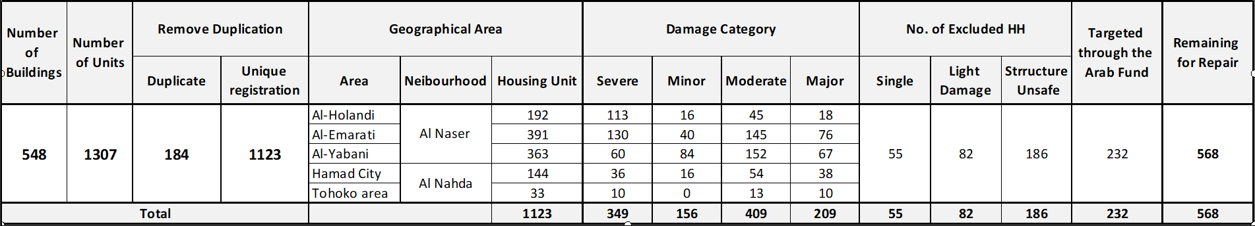
Status of UNDP Detailed Damage Assessment (Housing Units):

Building upon the progress, UNDP will increase the number of rehabilitation sites, expand works to Gaza City and further optimize sequencing of work packages, and expand outreach to additional vulnerable households. Critical housing repairs for safety and functionality will scale up, enabling more families to return to their homes.
Annexes
Annex 1: Project Implementation Workplan
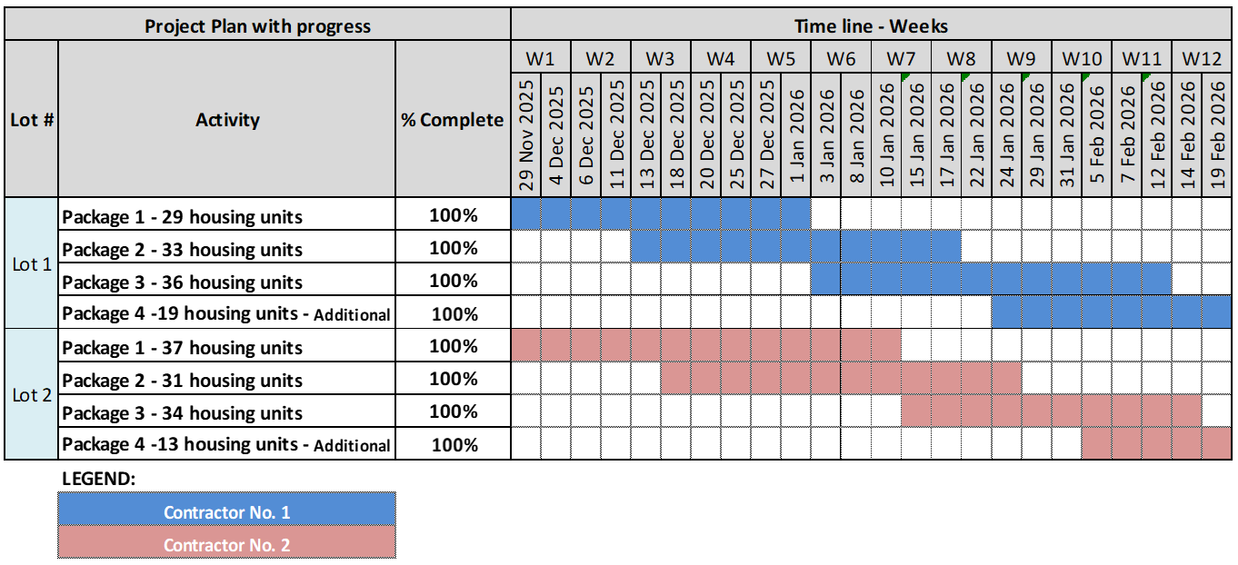
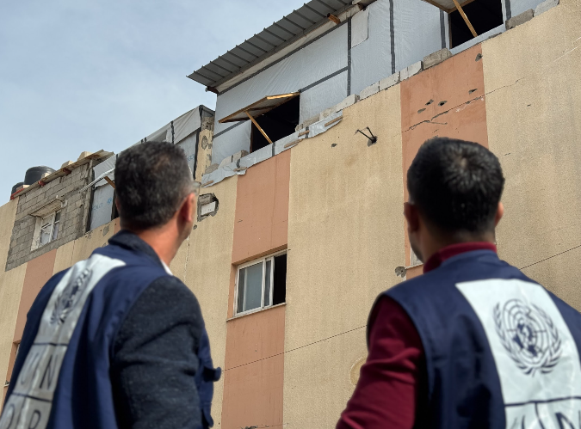
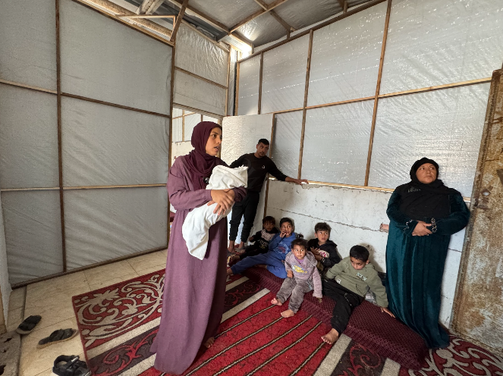
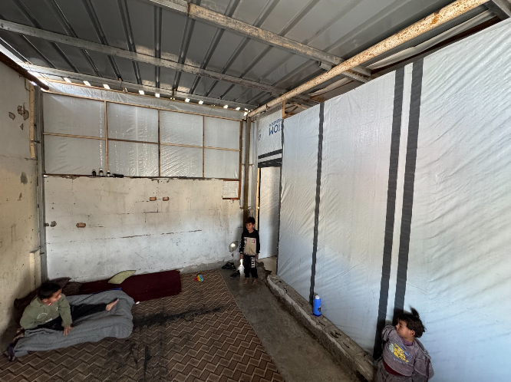
Annex 2: Image Gallery
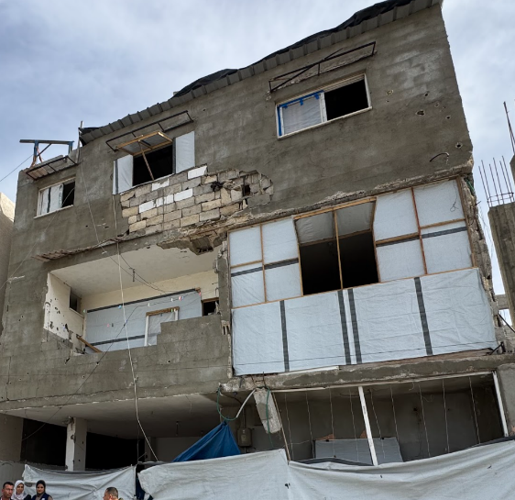
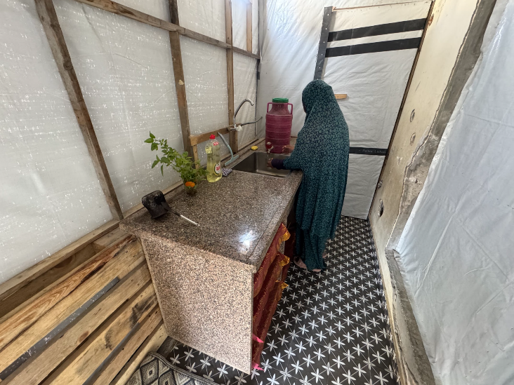
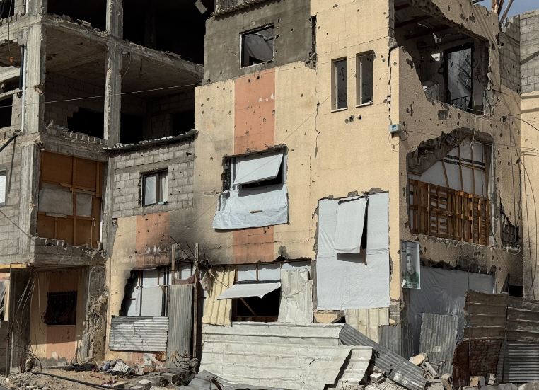
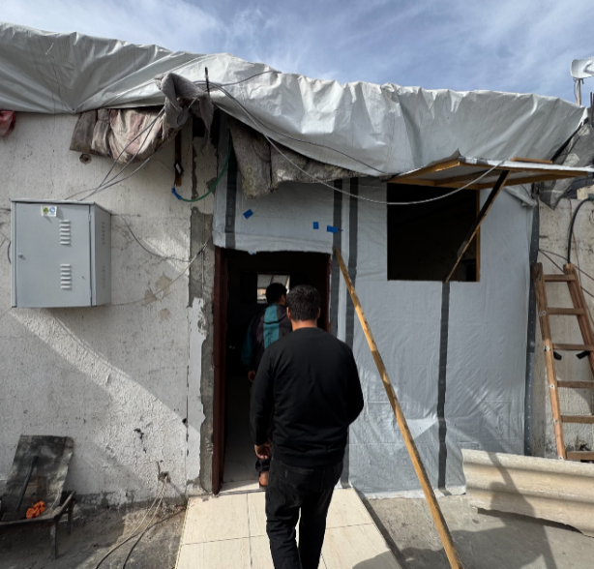
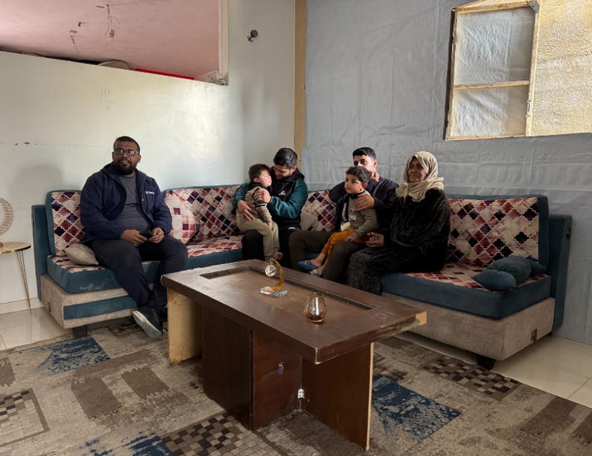
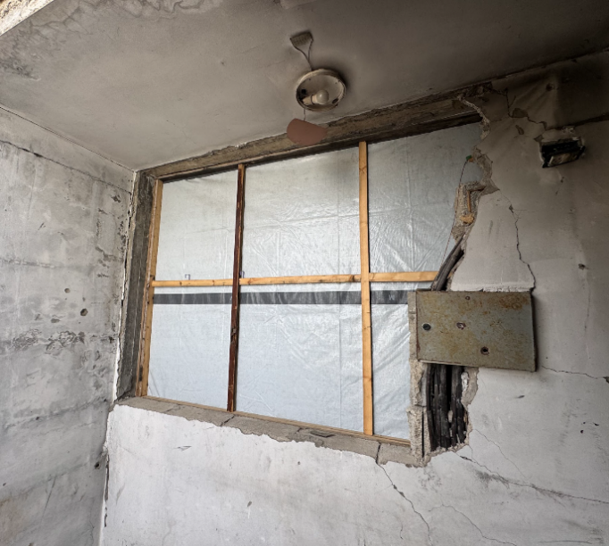
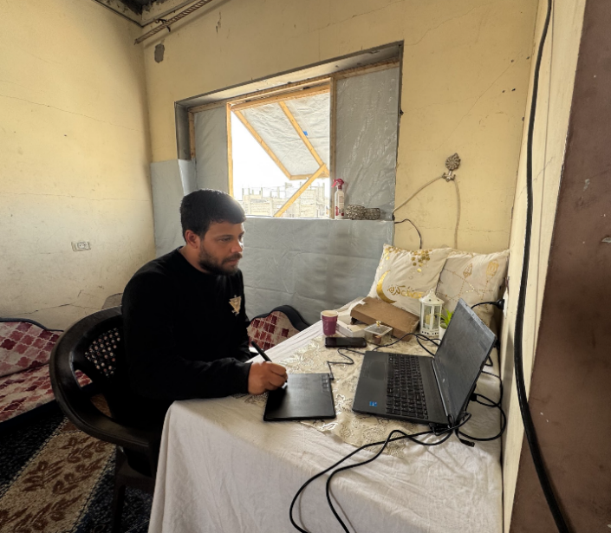
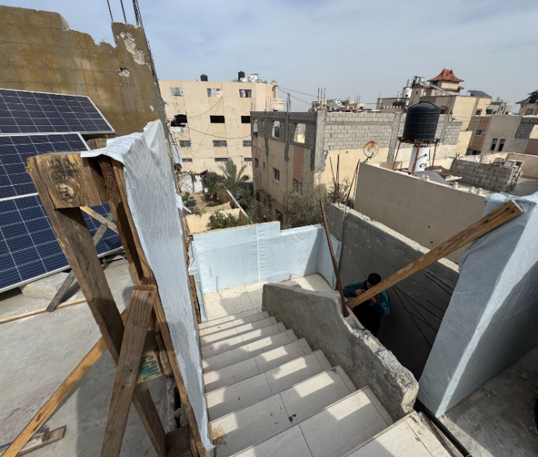
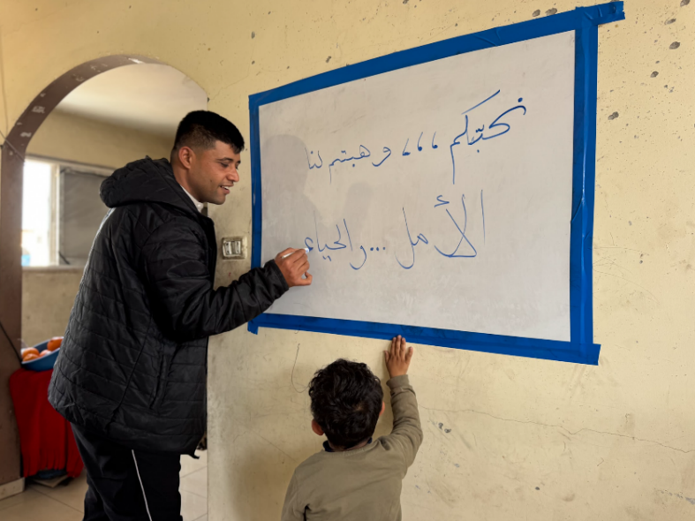

Annex 3: Before-After Comparisons
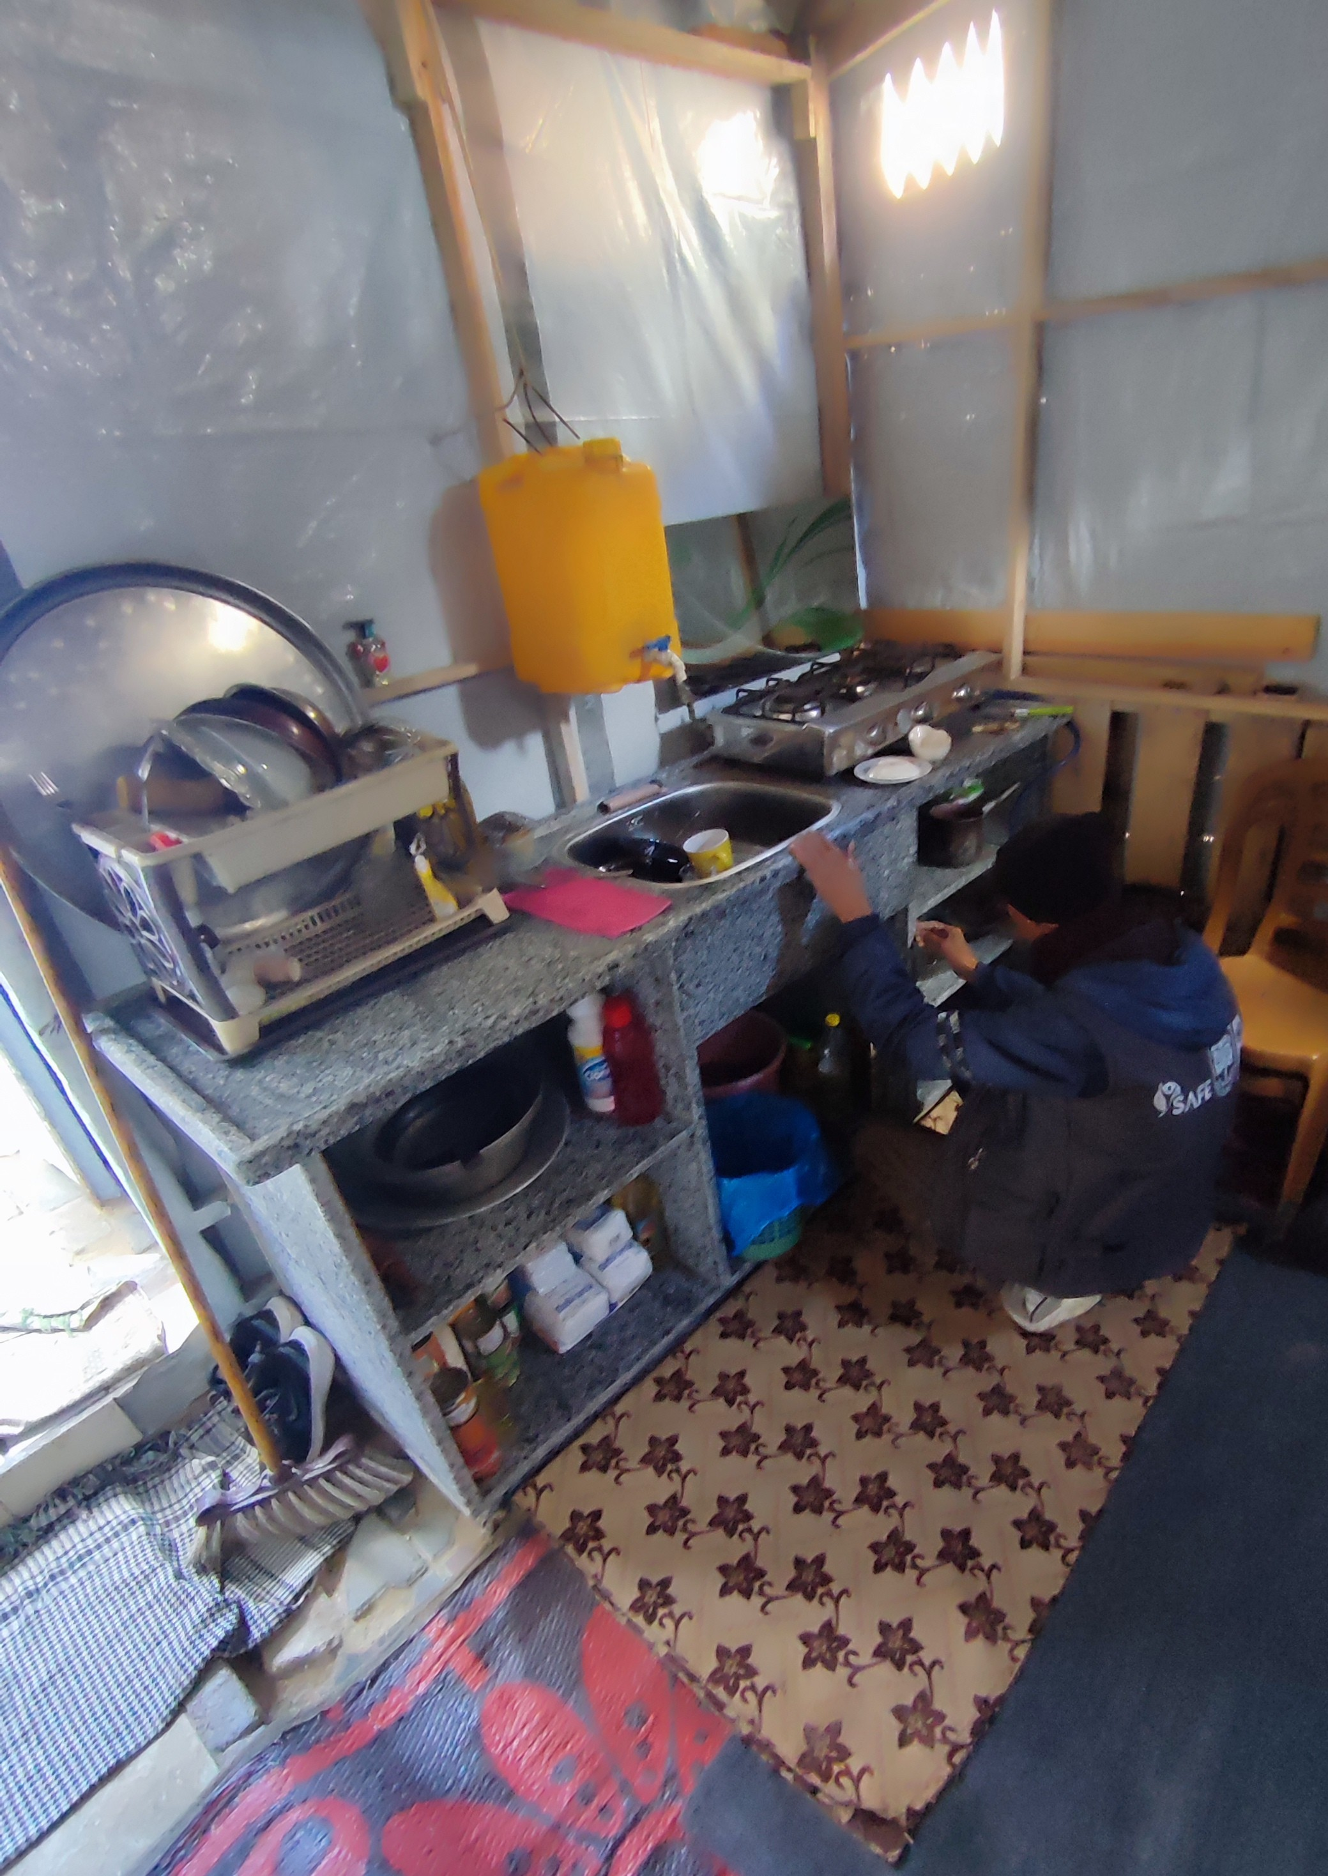
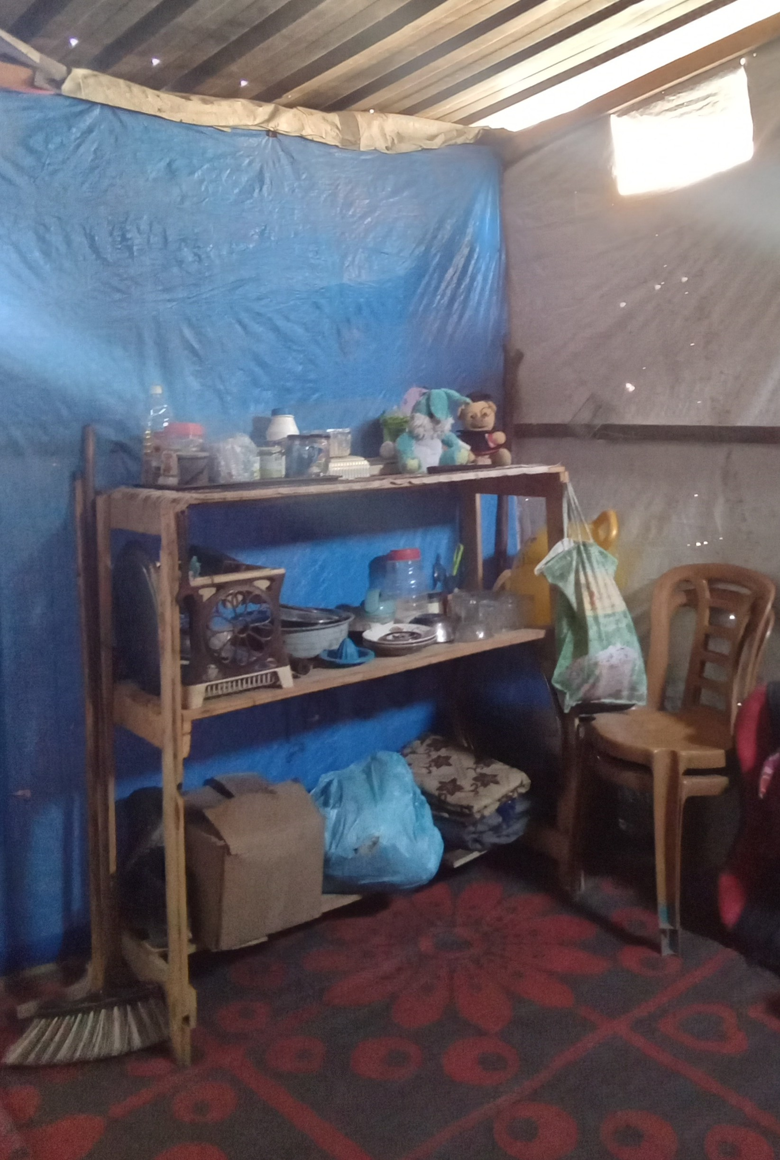
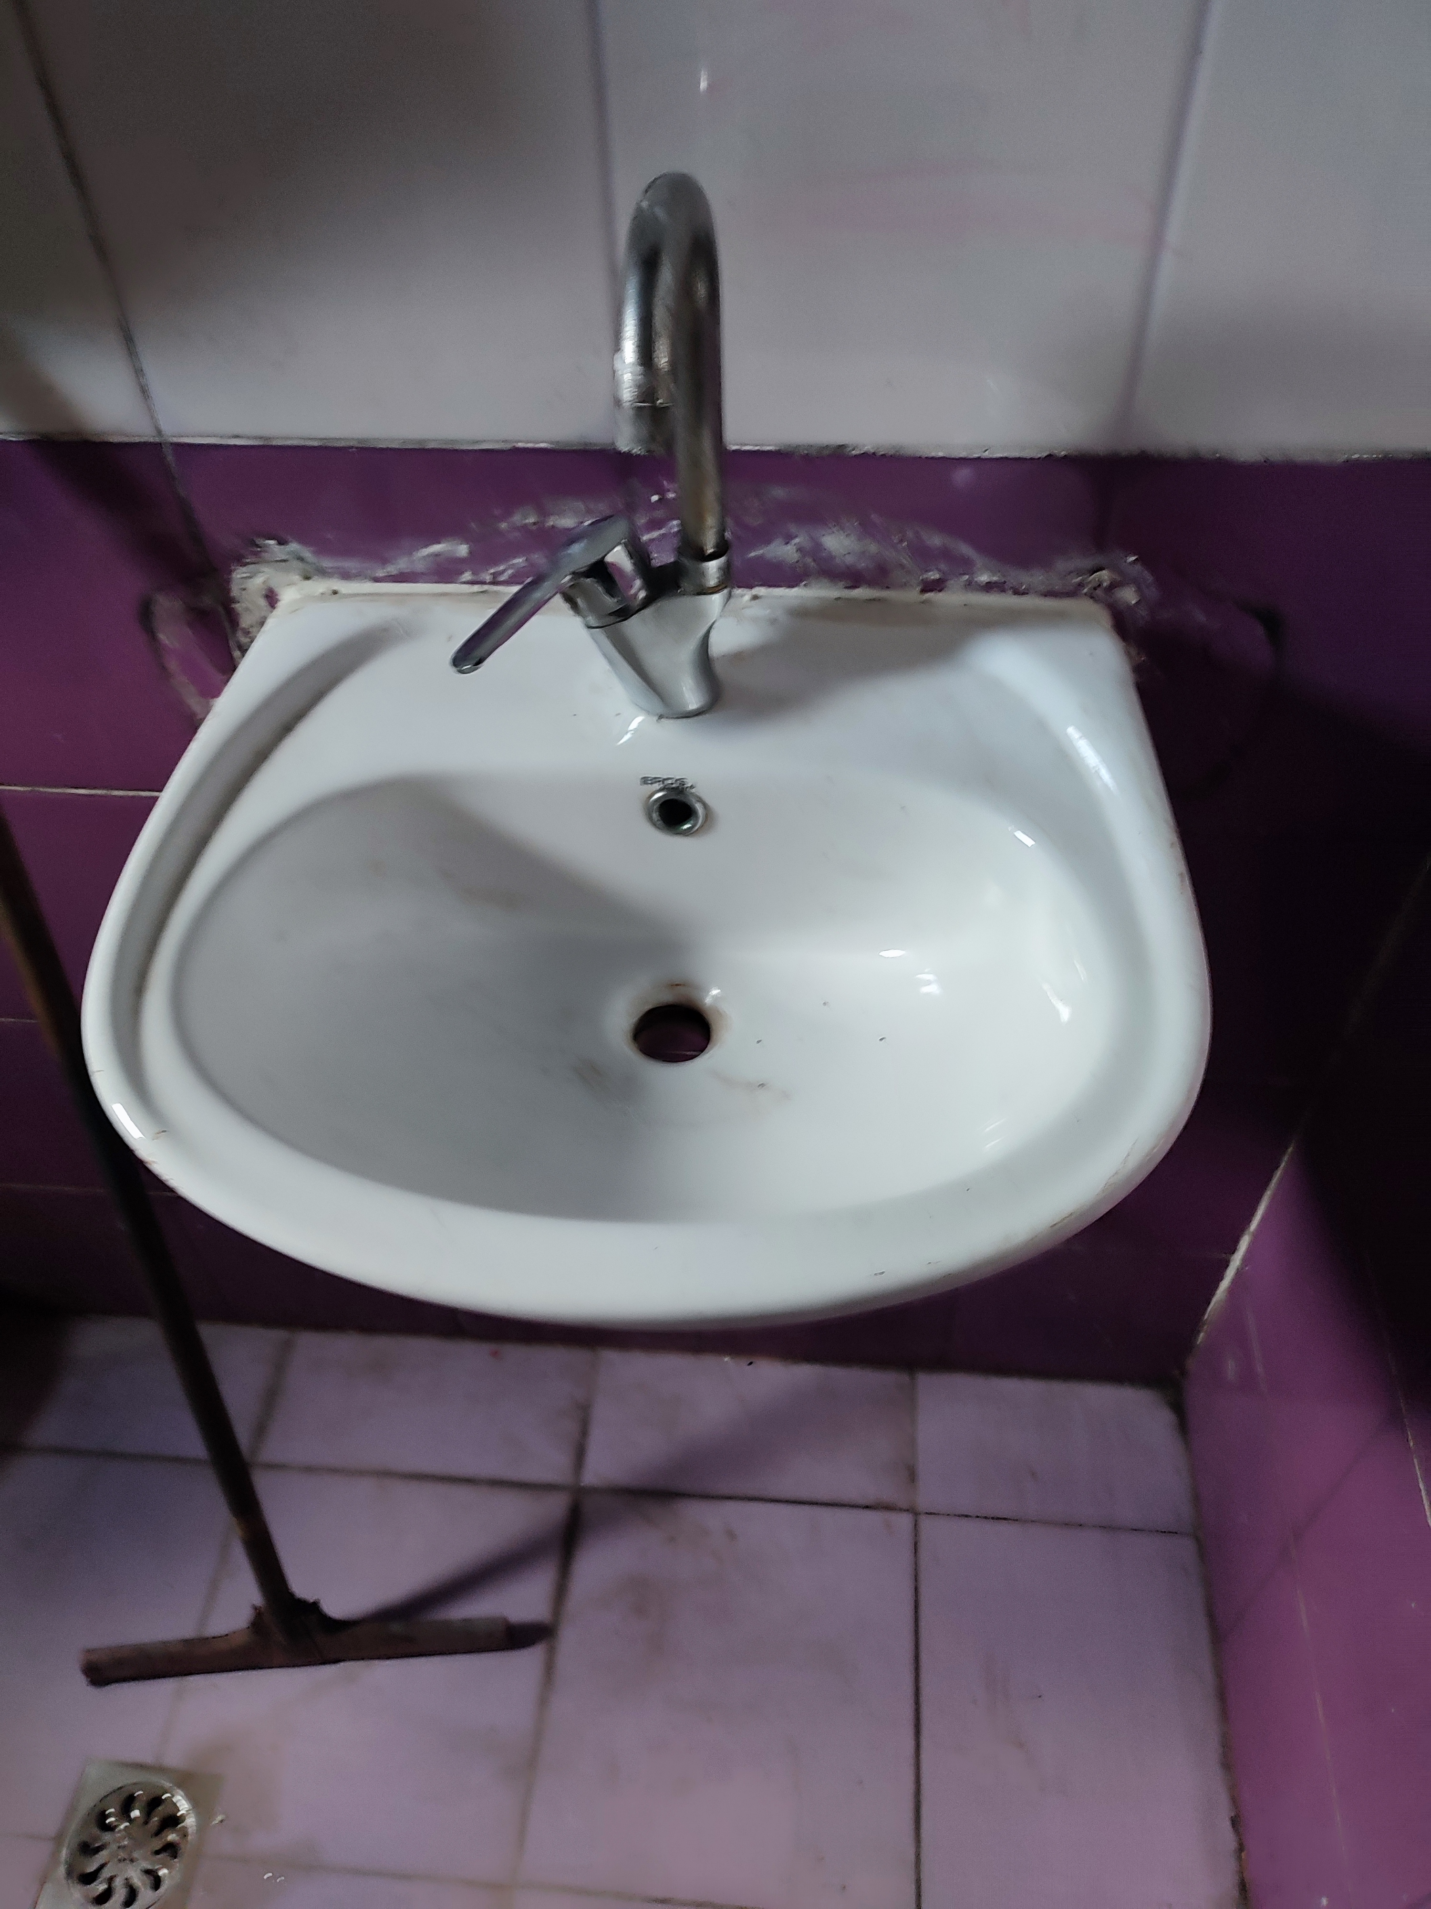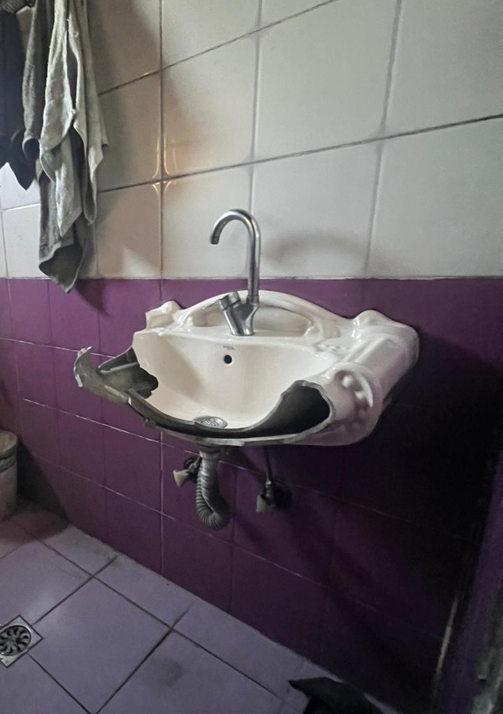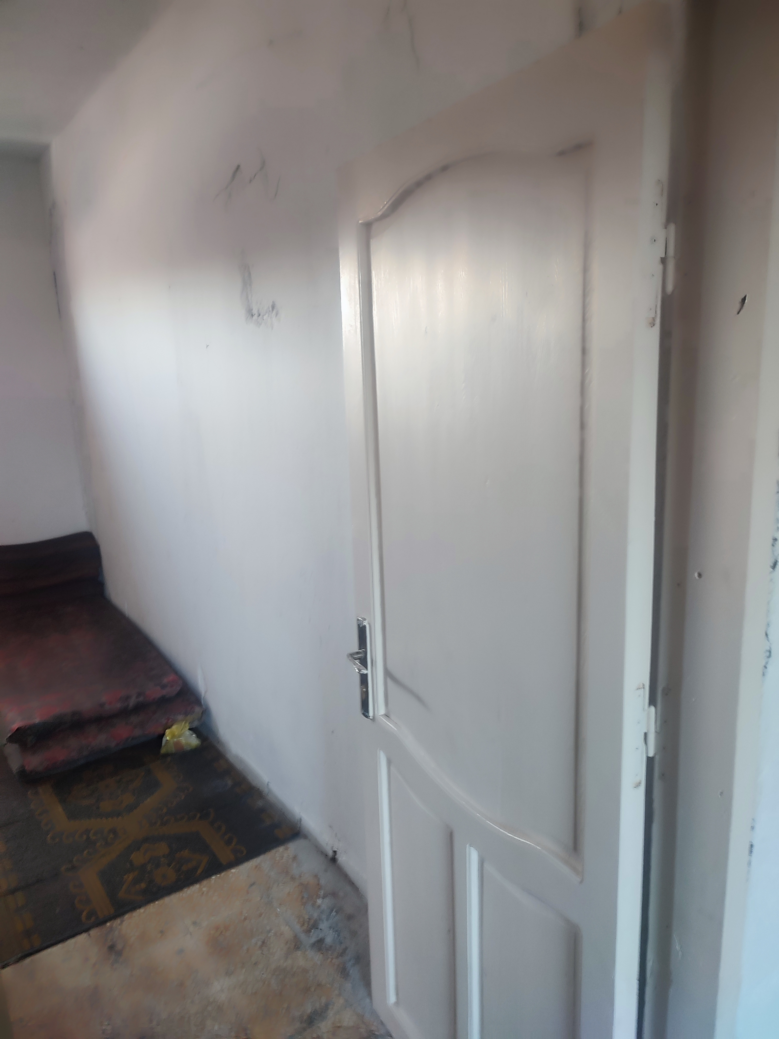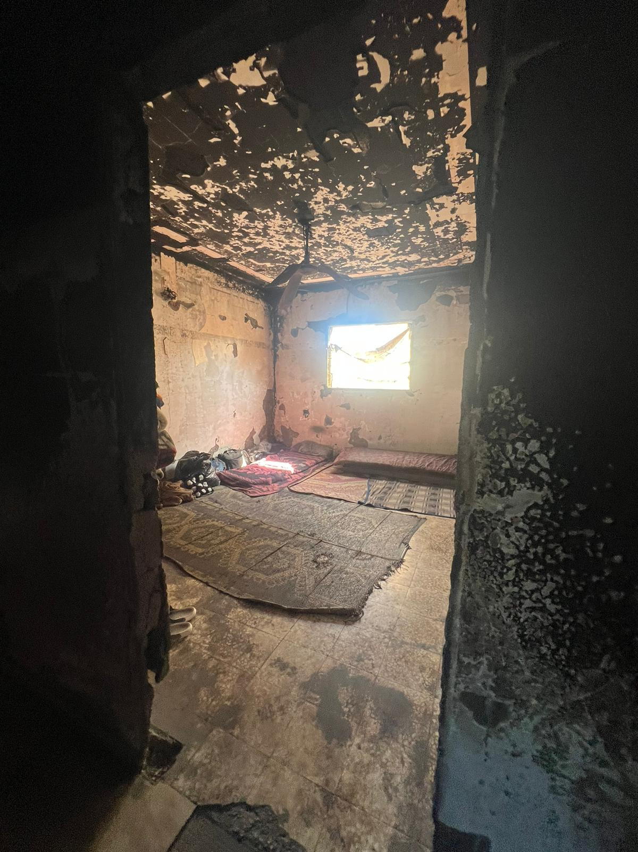

The kitchen was rehabilitated with a granite cabinet and fitted sink installed.

The broken sink basin was replaced and the washroom’s functionality restored.
Burnt internal walls were treated and painted, and the room was fitted with a new wooden door and frame.

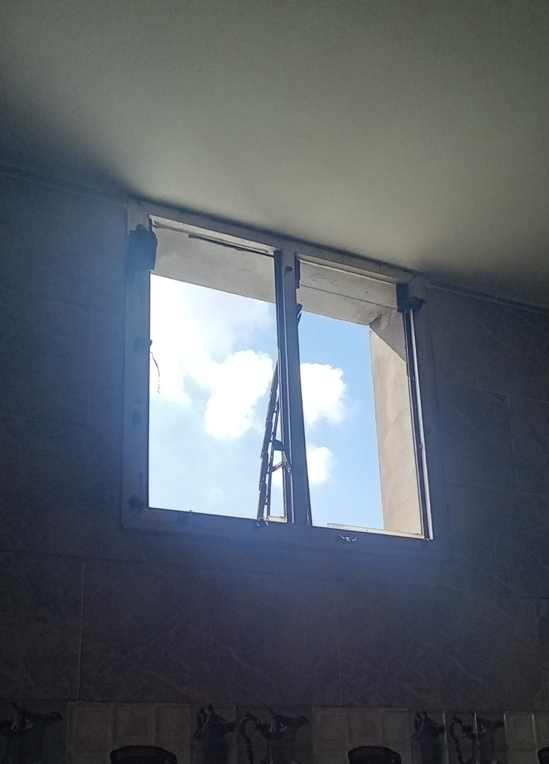
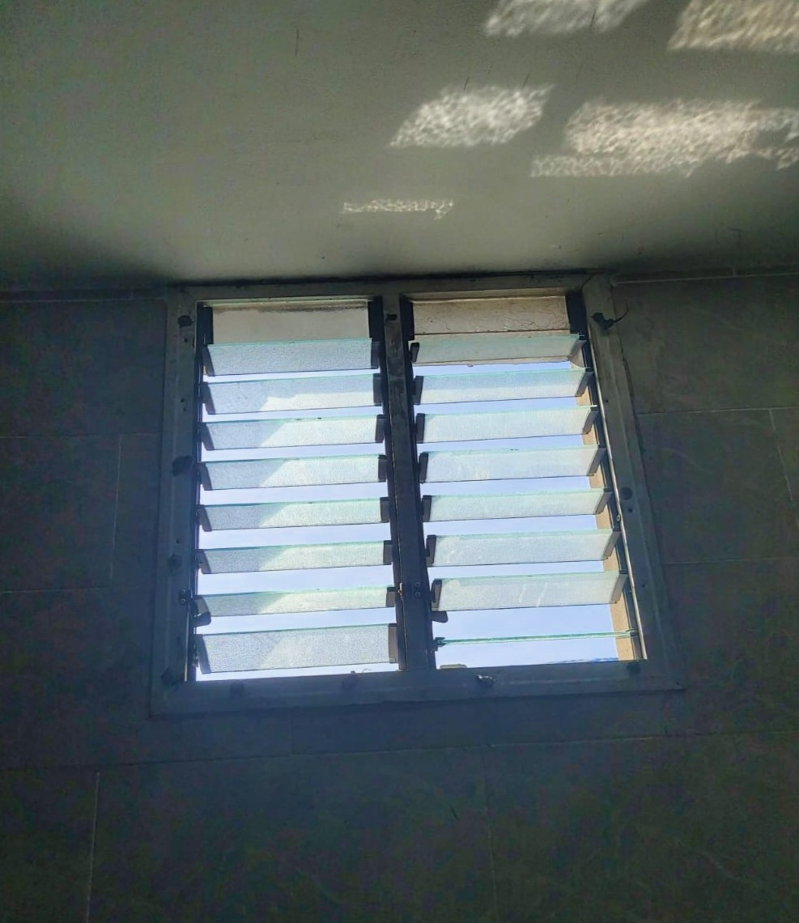
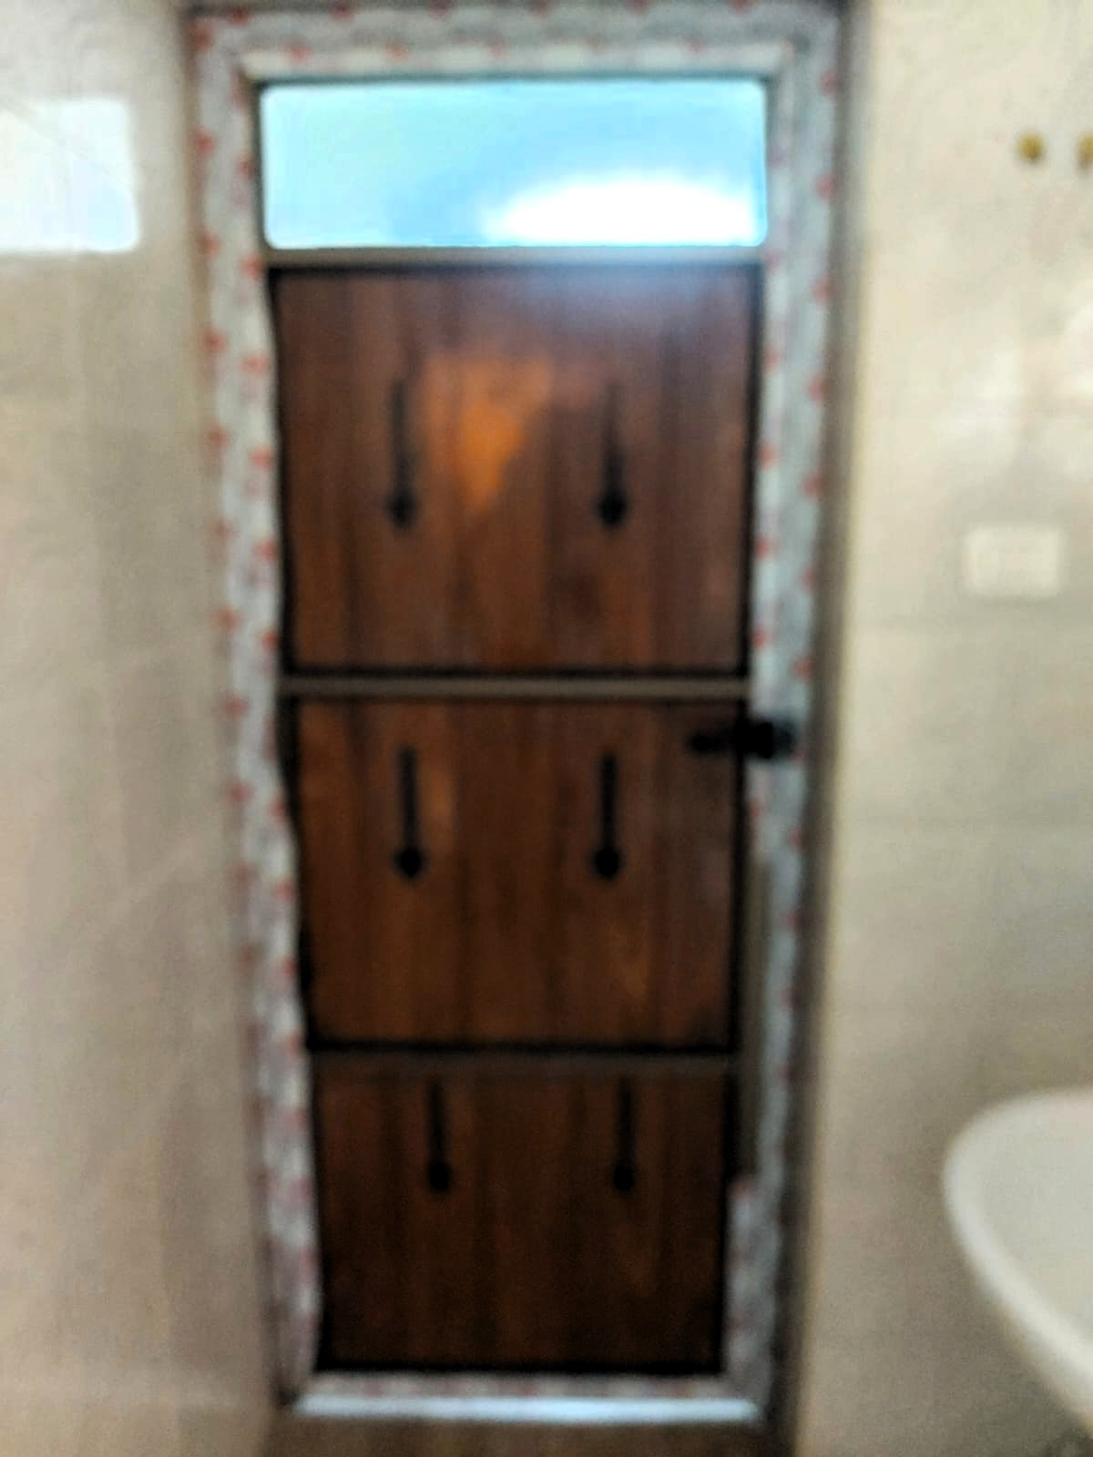
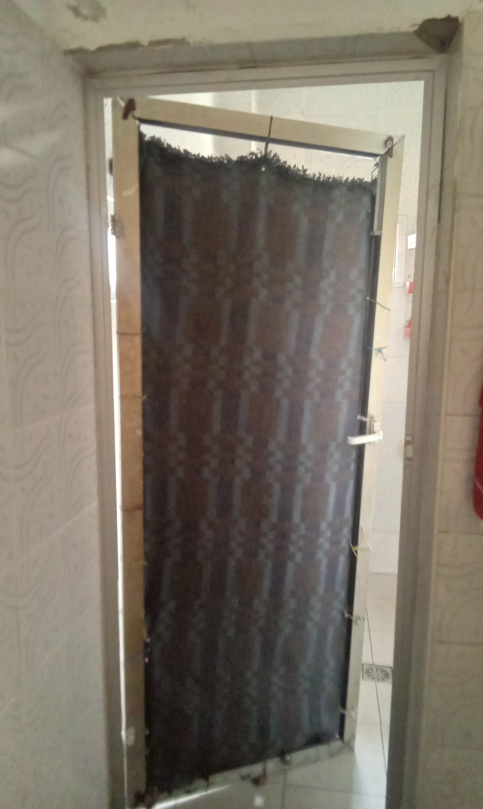
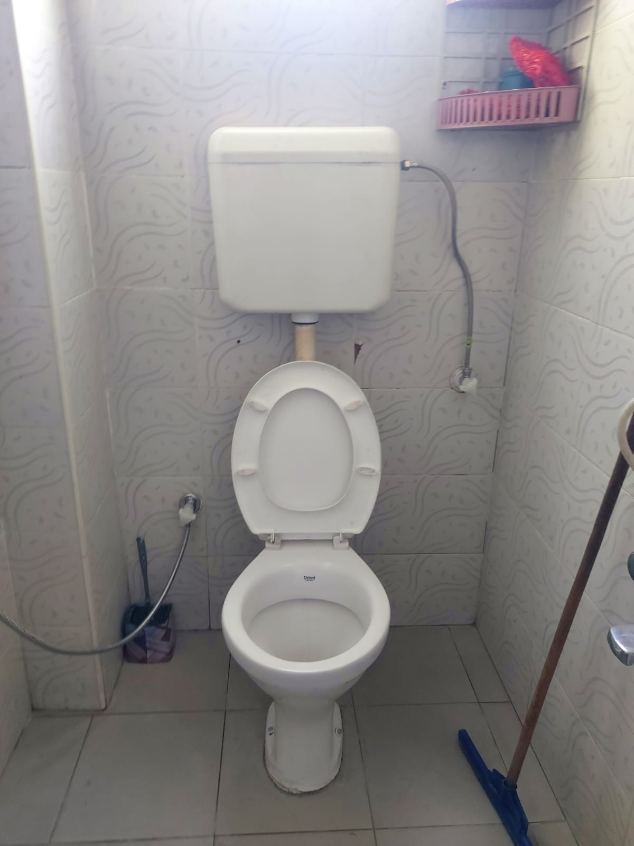
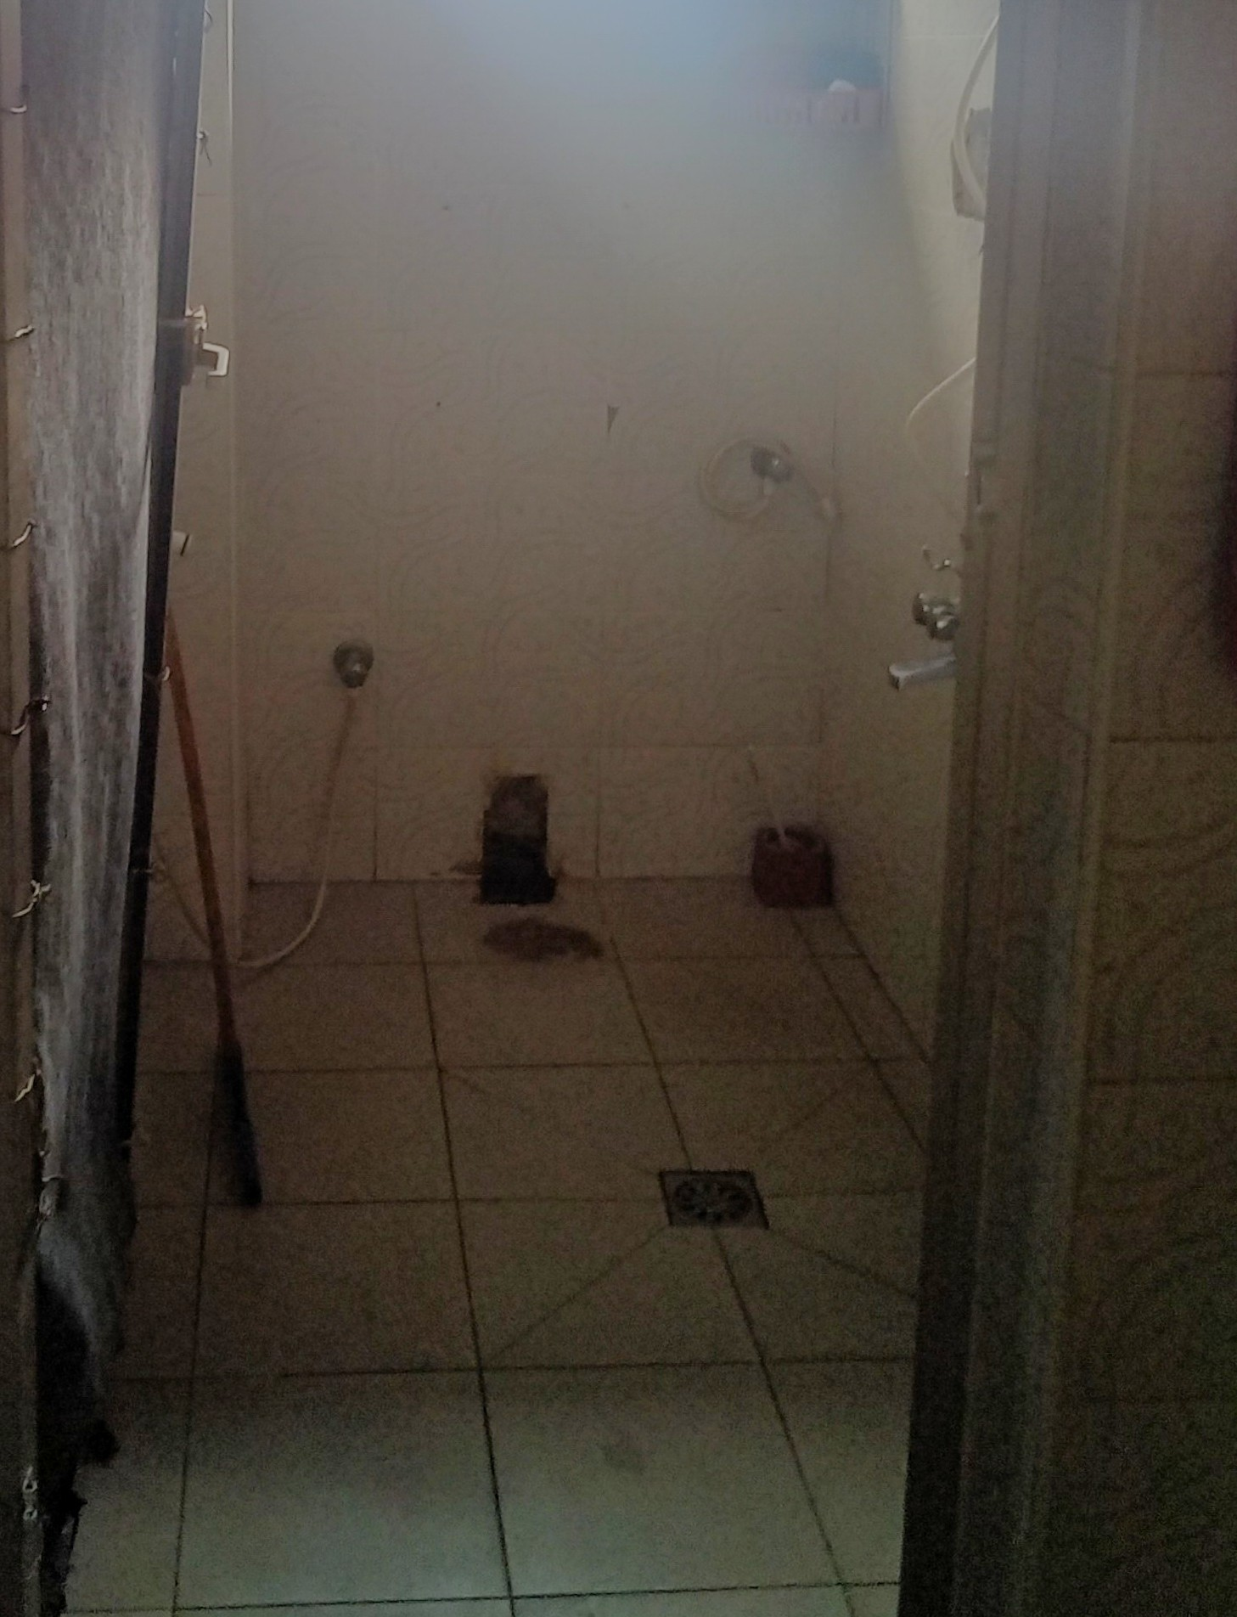
The bathroom was fitted with a new toilet, flush tank, and proper connections, improving sanitation and hygiene conditions.

The broken bathroom window was repaired and fitted with new glass louvers.
The bathroom was fitted with a new door for privacy, replacing a makeshift cloth separation.

